**UNITY OPEN LAB**

**Summary of Survey Results**

We based our survey off of the template from the [usability website](https://www.usability.gov/how-to-and-tools/methods/system-usability-scale.html) and adjusted questions based on relevance. The results we gathered came to one conclusion, while we did learn from the Open Lab course, none of us really enjoyed it, would recommend it, or want to use it again.While we all found the modules simple, they weren’t better than watching a YouTube tutorial on the same content, and we had to email tech support for the course to allow us to continue.

**Open Labs Overall Feedback**

* Only make users answer questions they got wrong. Having to retake the tests over and over was so frustrating. It felt like such a waste of time and a true punishment.
  + I started just only answering the harder question on a freebie attempt anyways…
  + The question about where to find components took much longer than needed just because I wasn’t even sure if the videos answered it.
* Loved how the tutorial videos were short and broken out by task
  + While at the same time some were longer than needed to be and could have been combined into one 10 minutes video.
* Loved the unlimited attempts
* Not being able to progress to the final [Self-evaluated Assignment: Create a kickball scene in Unity] was really frustrating
* The kickball scene assignment felt unfulfilling because, while it combined the skills previously learned into one assignment, it wasn’t engaging enough to feel like I was really putting my new knowledge to a new task.
* Overall, there was very little to learn and do, most of the time I spent learning was watching fluff in the videos or redoing assignments because I got a question wrong. I feel like I did very little with Unity itself. It felt like the very beginning of a much longer learning experience, but stretched out much longer than needed.
* The modules left me wanting more. Yes, I can create a scene, but how do I interact with it?
* Was expecting a more in-depth dive into learning unity but the modules are only a very, very basic introduction
* Modules should be expanded beyond just getting familiar with general unity interface

**Pre-requisites**

**PROS:**

* Establishing ground rules for academic integrity

**CONS:**

* Extraordinarily irritating, feels unnecessary
* A barrier to entry that literally is wasting time
* I don’t think students need to know if Open Lab will help staff at all risk postures
* Most of information presented was not applicable to the virtual lab

**LEARNED:**

* A little bit about resources available
* Open Labs allows access to resources students may not normally have encountered

**TIME:**

* 30 minutes

**BUGS:**

* n/a

**Module 1: Getting Started with Unity**

**PROS:**

* Liked the short video format

**CONS:**

* Don’t love the “you will need to get them all correct” vibe, anxiety inducing and doesn’t leave room for lecturer error
* The initial text introduction is very goofy while not actually funny. This was also a very off-putting and different feeling from the rest of the course.
* Wished there was more screen shots of the process of downloading unity software

**LEARNED:**

**TIME:**

* 30 minutes

**BUGS:**

* The first question has a duplicate answer

**Module 2: Editing Projects: Overview**

**PROS:**

* Good foundational content

**CONS:**

* Ins and outs of Unity Editor
* They barely tell us anything I wouldn’t have learned from hovering over the tools or just clicking on the dropdowns. An example of this is that the video didn’t say how the help menu could help you, just that you could use it.
* Only says to use the LTS version but not which and this messes up users if they use the 2020 LTS.
* For the first video, top of the screen is kind of cut off so a little hard to see what she’s talking about

**LEARNED:**

* Basic Unity facts

**TIME:**

* 30 minutes

**BUGS:**

* **#1**
  + **BUG NAME:** Error in [Self Check: Unity Basics] Quiz, Question #1
  + **SUMMARY:** Quiz one has duplicated options for question. Selecting one option results in getting 50% on question.
  + **DESCRIPTION:** Remove extraneous option from [Self Check: Unity Basics], question #1 to solve confusing user experience.
  + **REPRODUCTION STEPS:**
    - Go to quiz for [Self Check: Unity Basics] (link: <https://canvas.pitt.edu/courses/42220/quizzes/86181>)
    - Review Question #1: [The Unity Hub is best described as [ Select ] while the Unity Editor is [ Select ]
    - Two duplicated options exist (i.e., [a tool for working on your projects])
  + **EXPECTED BEHAVIOR:** Correct answer works, no duplicated options.
    - **Answer:** The Unity Hub is best described as a [project management tool] while the Unity Editor is [a tool for working on your projects].
      * **Side note:** Remove space before period.
    - Only one [a tool for working on your projects] option exists in second field
  + **OBSERVED BEHAVIOR:**

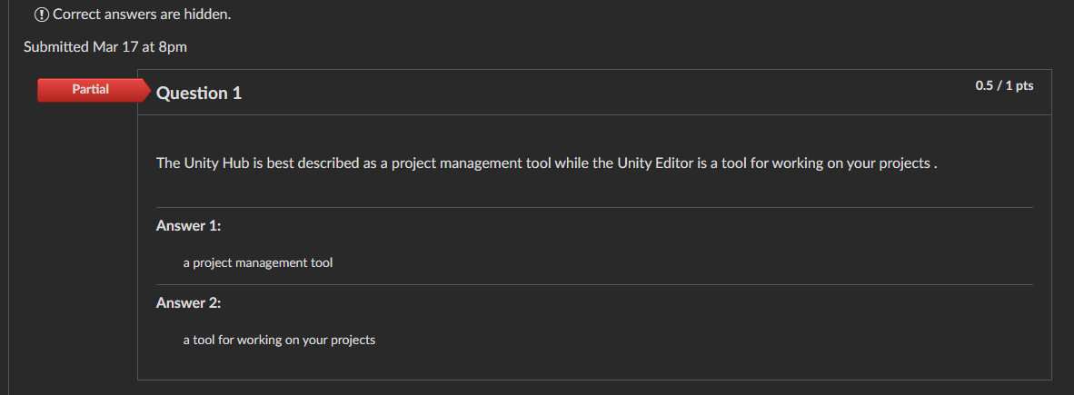

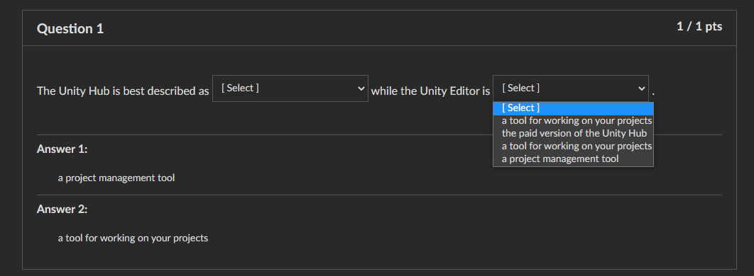

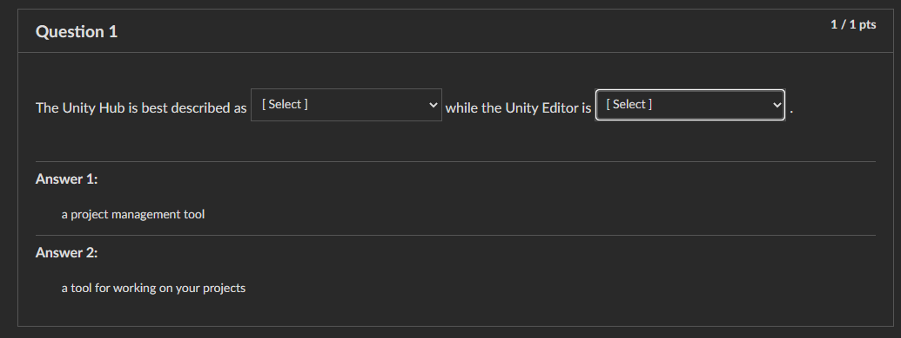

* + **IMPACT:** Medium
  + **SEVERITY:** Medium
  + **WORKAROUND:** n/a
  + **NOTES:**
    - User experience notes:
      * A bit confusing interaction
      * Frustrating since there are strict standards for continuing
      * Unlimited options are great though!

**Module 3: Mad Editing skillz**

**PROS:**

* Downloading assets that are premade is really empowering, letting us stand on the shoulders of giants
* The controls are really well covered
* Loved the shortcut cheat sheet

**CONS:**

* Quiz doesn’t auto pass. Users can’t progress
* 8 question test, one question tripped up; so I had to redo a few times, which was frustrating
* Didn’t feel like I understood how to interact with models
* Didn’t feel like I learned anything that would help with making a game specifically.
* Downloading assets took a long time
* Need to show how to open the asset store if it was closed or not there initially.
* More direction, tutorial like content on what we need to do for quizzes would be useful
* Was not confident that my submission for quiz two was qualifying
  + For context: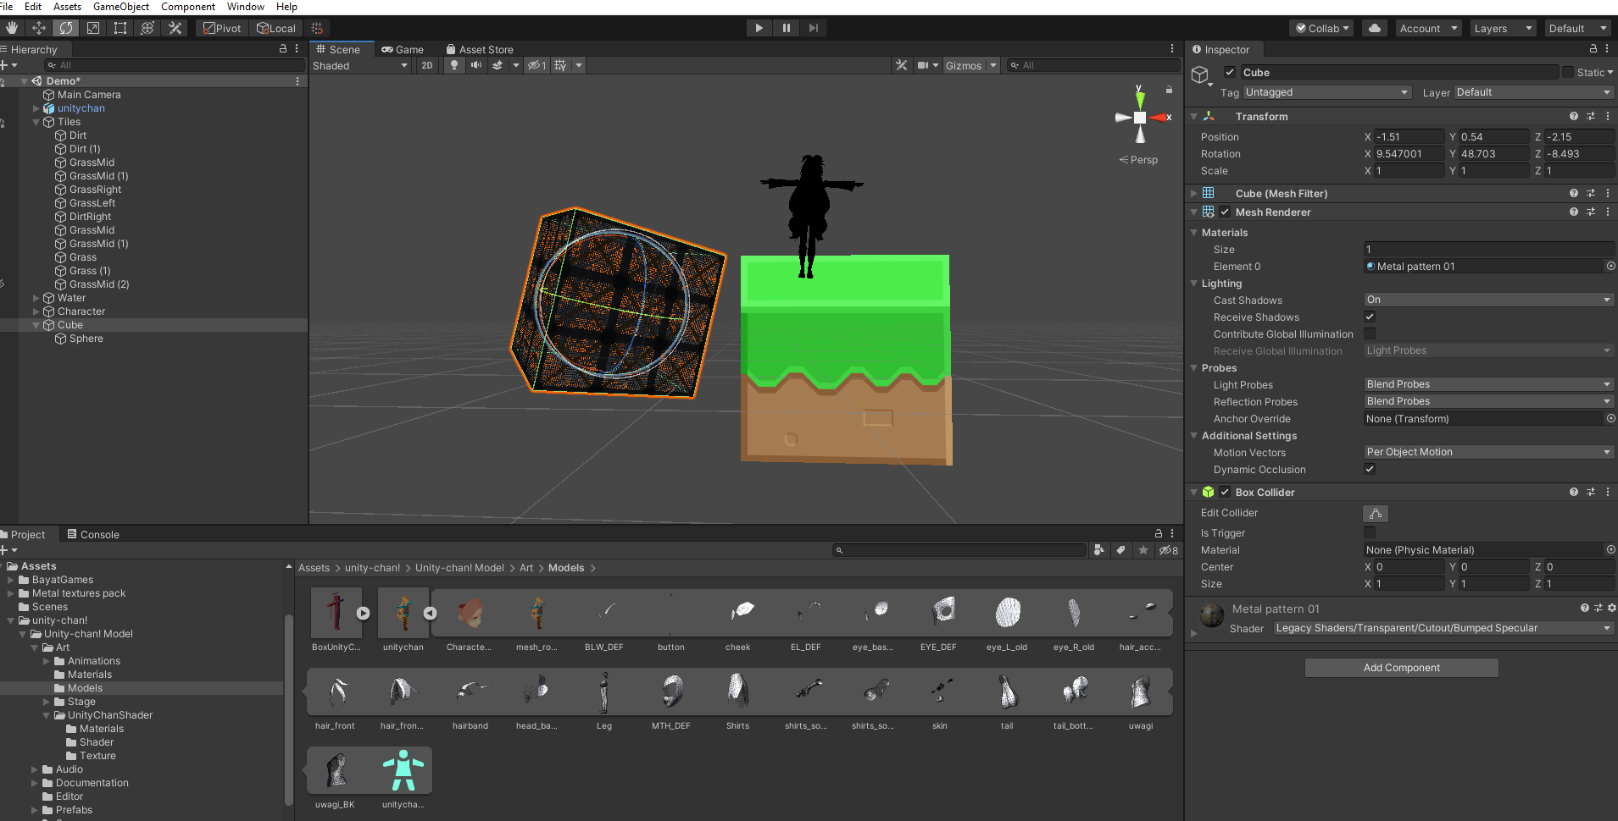

**LEARNED:**

* About models and material
* Basic UI controls

**TIME:**

* 50 minutes

**BUGS:**

* **#1**
  + **BUG NAME:** Stalling [Self Check: Unity Materials & Assets] Quiz, Question #2
  + **SUMMARY:** We can’t move forward unless everything is correct, but there is a “self-assessed” assignment that’s not yet graded. Not clear if we’re supposed to wait or if this is an error.
  + **DESCRIPTION:** We can’t continue in the modules until Question #2 is graded, but it’s suggested throughout the course that no one is grading. Unclear on how to proceed here.
  + **REPRODUCTION STEPS:**
    - Navigate to [Self Check: Unity Materials & Assets] (link: https://canvas.pitt.edu/courses/42220/quizzes/104129)
    - Add attached image
    - Submit
    - Grade appears
    - Click [Next] to go to [Self-evaluated Assignment: Create a kickball scene in Unity] assignment (link: https://canvas.pitt.edu/courses/42220/assignments/337386)
    - Get error message, “This assignment is part of the module Introduction to Unity and hasn't been unlocked yet.”
  + **EXPECTED BEHAVIOR:** We’re able to access the[Self-evaluated Assignment: Create a kickball scene in Unity] as soon as we: get question #1 correct and submit an image for question #2.
  + **OBSERVED BEHAVIOR:**

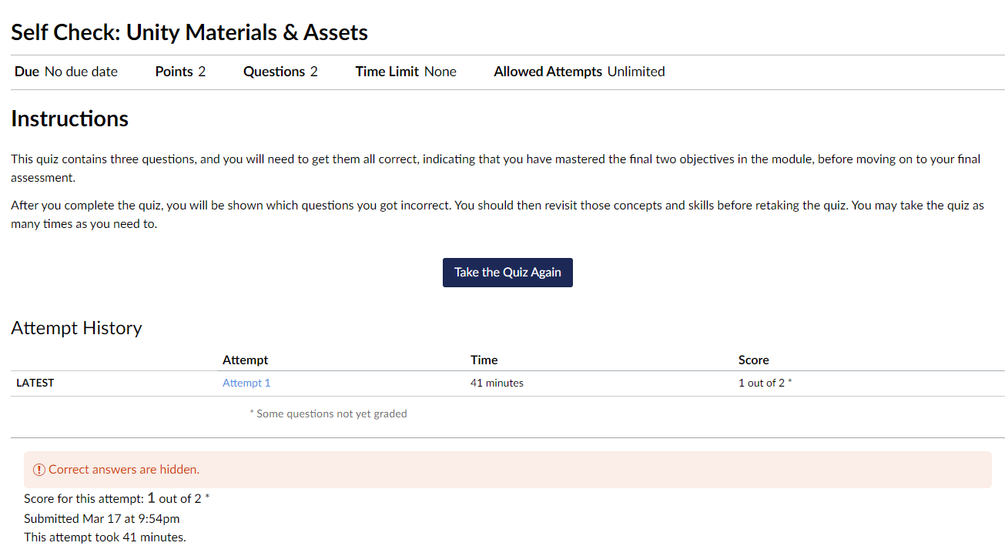

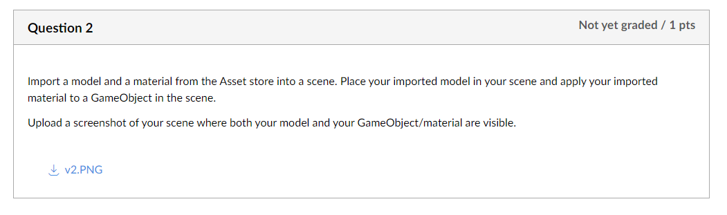

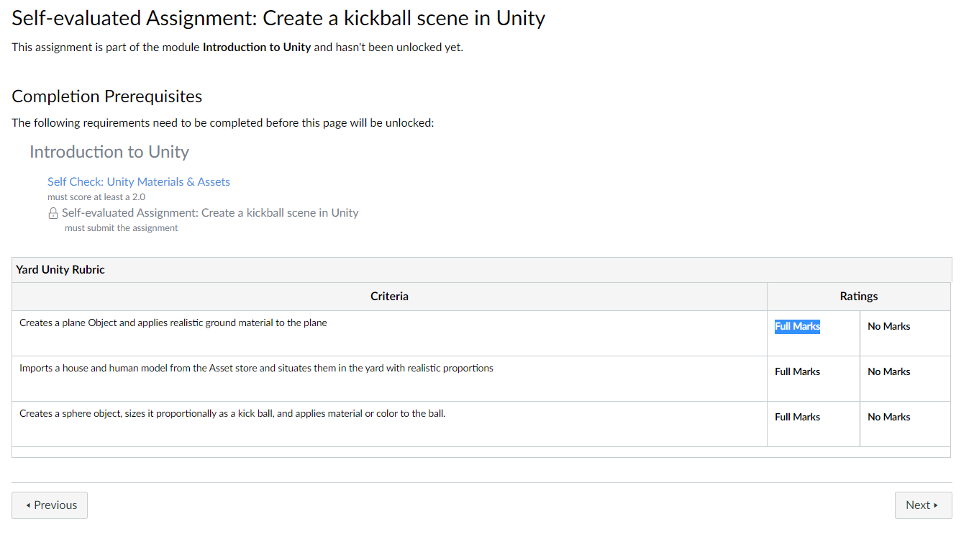

* **IMPACT:** High
* **SEVERITY:** Medium
* **WORKAROUND:** n/a
* **NOTES:**
  + - User experience notes:
      * This roadblock for learning was particularly frustrating.
      * If I wasn’t evaluating this for a class, I would have dropped off here. Because I don’t want to bother anyone and there are other, less irking options for learning Unity.
* **#2**
  + **BUG NAME:** Optimization in [Self-check: Unity Editor Basics] Quiz, Question #8
  + **SUMMARY:** Options within question #8 have no discernable order. Ordering from A-Z would make answering questions more intuitive.
  + **DESCRIPTION:** Sorting sets of options in an alphabetic order would be useful for student and overall more intuitive UI design.
  + **REPRODUCTION STEPS:**
    - Navigate to [Self-check: Unity Editor Basics] (link: <https://canvas.pitt.edu/courses/42220/assignments/413378>)
    - Question #8, Matching
    - Options should be listed in an order (recommended A-Z)
  + **EXPECTED BEHAVIOR:**
  + Matching options (e.g., [move left], [move up], etc.) in some order (e.g., alphabetical).
  + **OBSERVED BEHAVIOR:**

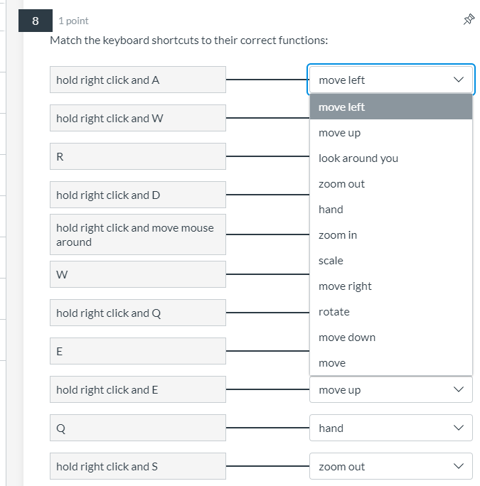

* **IMPACT:** Low
* **SEVERITY:** Low
* **WORKAROUND:** n/a
* **NOTES:**
  + User experience note:
    - Having to redo tests when you got any questions in the quiz wrong, plus this became irritating to deal with.

**Module 4: Putting it all together**

**PROS:**

* Tested my skills to create a scene
* Was able to reinforce learnings from previous modules

**CONS:**

* Not able to access until previous quiz has been graded
* The assignment was fairly unclear, it would be good to show some examples and ideas beforehand
* The assignment was barely any different from the last one. It was just this time we imported a few more assets. I get that it’s a review/wrap-up but it didn’t feel fulfilling. Maybe it just needed a bit more difficulty.

**LEARNED:**

* How to place a ground plane and import multiple assets

**TIME:**

* ~30-35 minutes

**BUGS:**

* n/a

**James’ thoughts:**

**What is Unity and Why Should I Learn it:**

“What does this mean to us? We can use Unity to create gnarly video games (or other interactive media) with the most minimal headache possible! See below a demo of a Unity game created by a newcomer to the tool, much like yourself: Not too shabby for a beginner right? I am willing to bet my job at Open Lab* that you can create an even cooler game after going through these Unity modules... **and** have fun while doing it!

*my boss likes to fire people so don't let me down

Don't believe me? Well hey, there's only one way to find out the truth. I guess you'll have to download and install Unity to try it out for yourself. Fear not, as we here at the Open Lab will provide you with all the guidance and resources you need to be successful.” This was a very “Hello fellow kids” moment to start off with.

**Editing Projects Overview:**

**Learn: Unity Editor layout and basic functions**

The person in the tutorial gives the very useful advice of “Use the help menu if you need help I guess." The part of the video talking about the dropdowns was lacking and this was the most obvious example of it.

So I started with the 2020 version because it seemed to be the recommended and was listed as lts, but it doesn’t have the 2d Object option in GameObject. I’d recommend specifying to use the 2019 version lts.

**Learn: Unity Object Creation & Scene Navigation**

She says we’ll use the tools we already learned about, but we only learned about the drop downs along the top? The audio in this video keeps changing volume and quality, it’s a little distracting.

**Materials & Assets**

They need to give the other way of accessing the asset store because when I opened unity there wasn’t just a tab of it. At the end of the assets she said it was the “last of these videos,” that seems misleading. I can guarantee knowing how to move, rotate and scale objects is not enough to make any sort of game.

**Kickball Scene:**

Just putting stuff in a scene again is kind of a letdown for this. It feels weird that the last assignment is the same as the second to last.

Well, I did it. I don’t really have any thoughts beyond that probably because this could have been the first assignment. Maybe it was just that I thought there would be something beyond placing objects. I might have just had my expectations too high.

**Leela’s Thoughts**

**Module 1: Getting Started with Unity**

Pros:

* I like how easy it is to understand, and it really got the point across quickly.

Cons:

* I thought it was pretty easy to understand it. I would say the only con would be that it was super text heavy and maybe some people may need visuals or something.

Time: 30 min

Bugs:

* I personally didn’t experience any.

**Module 2: Editing Projects: Overview**

Pros:

* I like the short videos, they get the point across quickly and it was informative.

Cons:

* I feel that for actually learning Unity, this isn’t nearly enough information. I would like a more in depth learning of it.

Learned:

* Basic unity facts

Time:

* 20 min

Bugs:

* The bugs in the quizzes are really frustrating:
  + 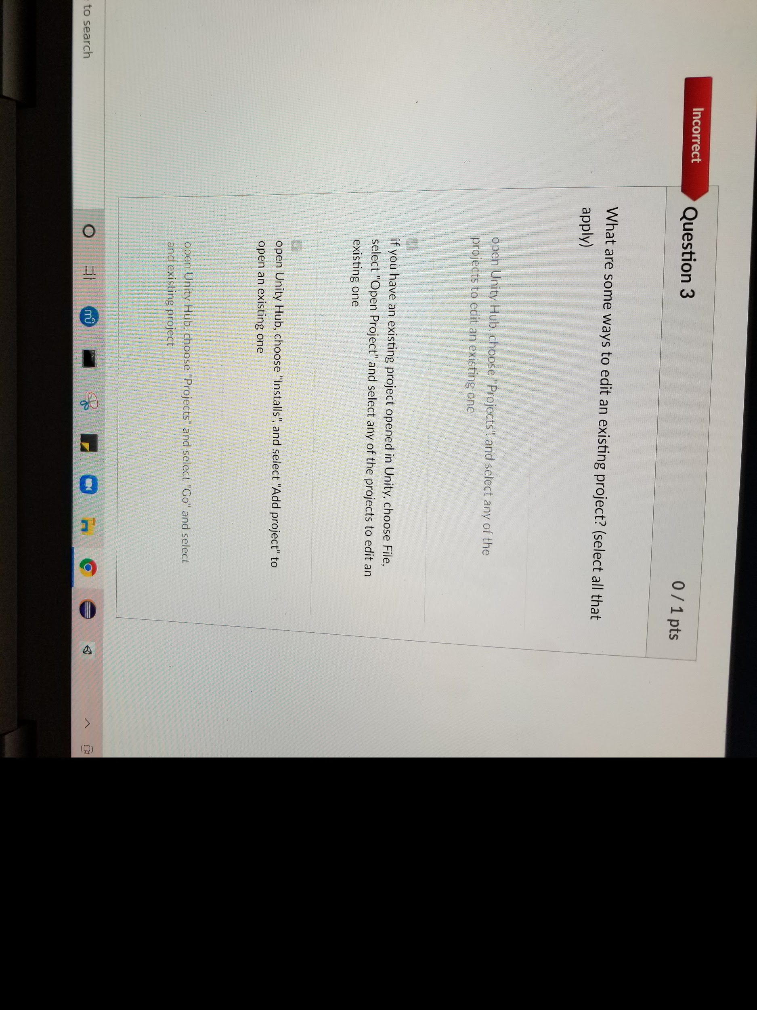
  + 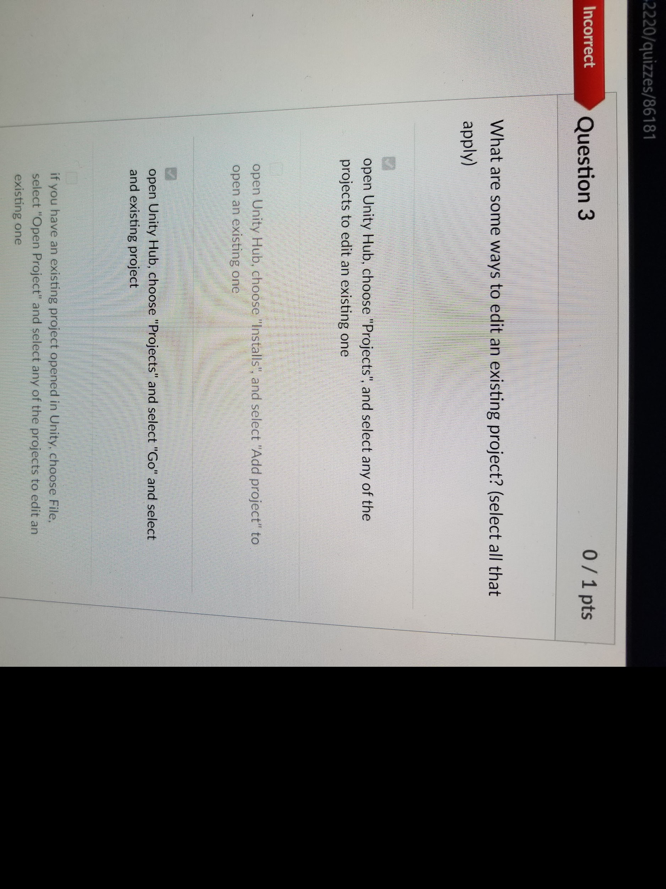
  + **BUG NAME: Question 3**
  + **SUMMARY:** In this particular bug, it shows that I got 0 out of 1 on this question for both of the inputs I had. At first glance, it seems that none of the options are right, but after contacting Open Lab, it seems that this question doesn’t actually take into account an answer choice that is right if you don’t choose all of the right answer choices. I think that should be fixed so students don’t waste their time like I did.
  + **DESCRIPTION:** Question 3 was showing that I got all answers wrong even though I chose some of the right answers.
  + **REPRODUCTION STEPS:**
  + **EXPECTED BEHAVIOR:**
  + **OBSERVED BEHAVIOR:**

**· IMPACT: Medium**

**· SEVERITY: Medium**

**· WORKAROUND:**

* + - **Had to go directly to open lab and contact them to fix it.**

**Module 3: Mad Editing Skillz**

Pros:

* Again, informative, gets the point across.

Cons:

* I feel like it’s just an intro, it doesn’t teach enough.

Learned:

* Using assets

Time:

* 30 min

Bugs:

* The self evaluation on the end of the module quiz - someone has to look through it so it prevents students from moving forward until then.

**Module 4: Putting it all together**

Pros:

* It’s nice and easy to put everything together

Cons:

* It was a bit lacking and didn’t feel like I did a whole lot.

Learned:

* We put it all together

Time:

* 30-45 min

Bugs:

* I personally didn’t experience any.

**Learn.unity.com Overall Feedback**

* Liked how after each section the module was evaluated
  + 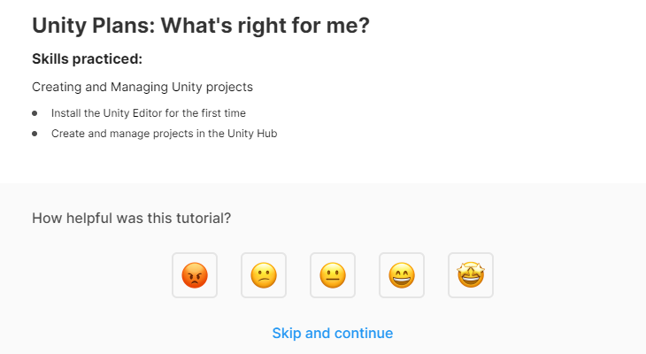
  + 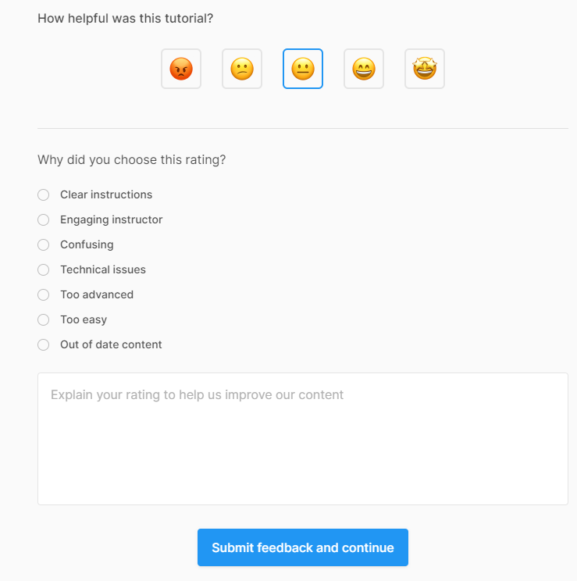
* Loved the videos on mindset for learning
* Loved videos on how different individuals learn
* Loved how content was broken out by tracks, chunked in small amount of information
* Loved the checks for each small section, gave a small sense of achievement and progress
* Loved how simple it was to quickly access and understand information
* Loved direct feedback on quizzes with explanations
  + 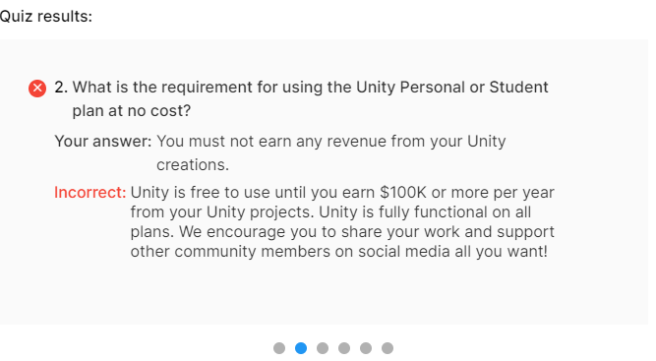
* Loved the concept of introducing microgames
* Didn’t like waiting for things to download (e.g., microgame took quite a while)

**Comparison between Learn.unity.com vs. Open Lab**

* The Learn Unity module is future proofed because it actually tells which exact version of Unity to install.
* Learn Unity acknowledges the microgames.
* Learn Unity introduces the Player GameObject and ways to change it.
* The Learn Unity tutorials actually teach something that I feel like is actually valuable and not just something I could figure out by hovering over the main tools.

**Appendix**

**SLIDES:** [**Link**](https://docs.google.com/presentation/d/1cgqbReCLPDCbDnvseSOJL4N9ZQhgT-io1Piyso_LLkU/edit#slide=id.gcaa815c9cc_0_119)

**SURVEY RESULT:**

* [**Survey**](https://forms.gle/U5wQKE4HuvJBZbNDA)
* [**Compiled results in .csv**](https://docs.google.com/spreadsheets/d/1K9el0i4SG0LAo5lmBkvHSu4A3IlALbppz7E0GB00rLA/edit?usp=sharing)

